Vista Travel

Overview

The Vista Travel demo and sample application demonstrate the use of Visual Studio.NET and the .NET Framework to create a next generation online travel site. Vista Travel is a fictitious travel company that contains a comprehensive database of profile and preference information about their existing clients. Vista wants to leverage this information in combination with web services provided by other organizations in the travel industry.

The end result of this effort is an online travel site that provides Vista Travel’s members with a single web site to handle all their travel needs.

For the latest source code and documentation visit www.vistatravel.net.

End User Scenario

The Vista Member logs on to the travel site looking for a quick escape vacation. The member isn’t sure where they want to go, but knows they would like to go skiing.

- From the Vista Travel Home Page, the user selects Skiing from the Escaping To Do drop down. The user leaves the other options empty and clicks Escape Now.

- The user is taken to the Travel Options page that displays a list of vacation options that match the users preferences. The user is interested in the Lake Tahoe vacation and drills into the prior visitor comments by clicking the Great bar in the grid. The user then selects one of the items to view the entire comment.

- The user clicks the View/Edit Full Itinerary and is taken to the daily itinerary detail page. This page contains a suggested daily itinerary of flights, activities and places to stay. Scroll through each day of the trip by using the Next and Back buttons.

- The user decides the Tahoe trips looks like what they want and clicks Book This Trip and is taken to the confirmation page.

- From the Confirmation page, the user decides to look into their dinner options for the first night by clicking the Dinner Options link.

- On the Dinner Options page, the user selects a restaurant and clicks the Save button. After clicking the save button, the user is taken back to the confirmation page where the restaurant has been added to their itinerary.

- The user clicks the Continue button to book the itinerary and is taken to the Thank You page.

Project Details

The Vista Travel web site is made up of a number of different Visual Studio.NET projects and solutions. In this section of the document we’ll provide you with a brief overview of the individual projects and their function within the application.

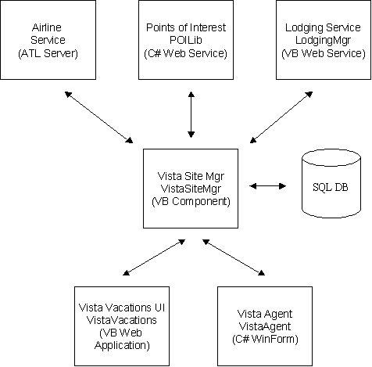
Figure1

Figure 1 provides an architectural overview of the pieces that make up the Vista Vacations application. Each individual service was developed using the Visual Studio.NET development environment.

AirlineService

The Airline Service is written using the new ATL Server feature of Visual Studio.NET. The airline information is exposed as a Web Service and stores it’s data within a SQL Server database.

The Airline Service is made up of two components, the ATL Server component (AirlineService) and an ISAPI filter (AirlineServiceISAPI). The ISAPI filter handles the packaging and unpackaging of the web service calls.

The source code for the lodging service is located at <install dir>\StandAloneProject\AirlineService

LodgingMgr

The Lodging Service (LodgingMgr) is a web service developed in Visual Basic. Like the airline service, the lodging information is exposed via a web service and the data is stored within a SQL Server database.

The source code for the lodging service is located <install dir>\WebServices\LodgingMgr

POILib

The Points of Interest Service (POILib) is a web service developed in C#. The Points of Interest service provides information about activities and services based on activity categories and proximity to a given location. The POI service is used by the VistaSiteMgr to identify vacations destinations based on the members profile. Once a given destination is selected, the POI service is used to gather the list of activities available at the destination.

The source code for the POI service is located at <install dir>\WebServices\POILib

VistaVacations

The Vista Travel site is made up of a library component and a web form application both developed in Visual Basic. The component handles the interaction with the Vista SQL Server database and the web services provided by Vista’s travel partners. The VistaSiteMgr component also encapsulates the business logic used to match members with travel destination based on their preferences.

The source code for the Vista Travel component is located at <install dir>\StandAloneProjects\VistaSiteMgr. The source code for the Vista Travel web site is located at <install dir>\WebSite\VistaVacations.

VistaAgent

In addition to their web site, Vista Travel provides a call center staffed with travel agents that can assist members in the travel process. The travel agents utilize the same services available on the web site in addition to other services. Vista Agent is a rich WinForm application used by the travel agents. Vista Agent was developed in C#.

The source code for the VistaAgent application is located at <install dir>\StandAloneProjects\VistaAgent.

